Grove - 433MHz Simple RF Link Kit
(Redirected from Grove - 433MHz Simple RF link kit)

Contents
[show]

Introduction
This kit is used for one way wireless communication at a frequency of 433MHz and includes a transmitter module and a receiver module. The twig configuration of this kit allows for around 40 meters of transmitting distance indoors, or around 100 meters outside.
Model: WLS01052O
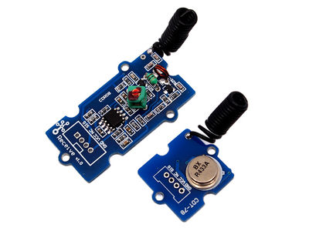

Features
- GROVE compatible interface.
- Uses ASK (Amplitude Shift Keying) Modulation.
- One way communication.

Specification

Transmitter Module
Item | Min | Typical | Max | Unit
Working Voltage | 3.0 | 5.0 | 12.0 | VDC
Current | 3 | / | 10 | mA
Work Mode | ASK |  |  | /
Transmit Power(Max) | 15 |  |  | mW
Working Distance | 40 | / | 100 | m

Receiver Module
Item | Typical | Unit
Working Voltage | 5 | VDC
Quiescent Current | 5 | mA
Receiver Sensitivity | -105 | dBm
Operating frequency | 433.92 | MHz

Application Ideas
- Remote control
- Remote automation
- Alarm

Usage
The transmitter and receiver modules both rely on a single wire for communication. Though using the UART supplied by the arduino platform can work, it is recommended, instead, to use the VirtualWire library which uses Amplitude Shift Keying for modulation which provides better communication.
Both the transmitter and receiver modules require three wires: Vcc, Ground, and signal. Pin 2 of both parts of the kit are not connected.
- Connect the Transmitter module to Digital I/O 2 of the Grove_-_Base_Shield on the arduino being used for transmission.
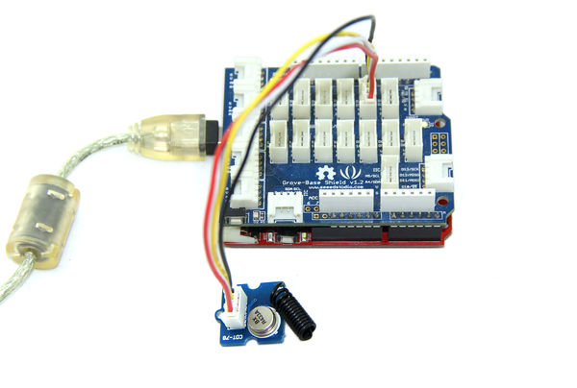
- Connect the Receiver module to Digital I/O 2 of the Grove_-_Base_Shield on the receiving arduino.
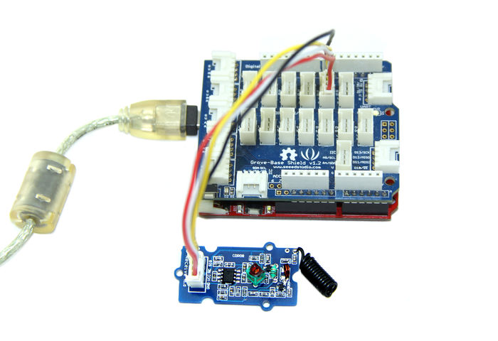
- Download the File: VirtualWire library and unzip it into the libraries file of Arduino IDE by the path: ..\arduino-1.0\libraries. Please referencehere.
- Upload the code below for transmitter module:

#include <VirtualWire.h>

//Grove - 315(433) RF link kit Demo v1.0
//by :http://www.seeedstudio.com/
//connect the sent module to D2 to use
#include <VirtualWire.h>

int RF_TX_PIN = 2;

void setup()
{
vw_set_tx_pin(RF_TX_PIN); // Setup transmit pin
vw_setup(2000); // Transmission speed in bits per second.
}

void loop()
{
const char *msg = "hello";
vw_send((uint8_t *)msg, strlen(msg)); // Send 'hello' every 400ms.
delay(400);

}
- Upload the code below for receiver module:
//Grove - 315(433) RF link kit Demo v1.0
//by :http://www.seeedstudio.com/
//connect the receive module to D2 to use ..
#include <VirtualWire.h>

int RF_RX_PIN = 2;

void setup()
{
Serial.begin(9600);
Serial.println("setup");
vw_set_rx_pin(RF_RX_PIN); // Setup receive pin.
vw_setup(2000); // Transmission speed in bits per second.
vw_rx_start(); // Start the PLL receiver.
}

void loop()
{
uint8_t buf[VW_MAX_MESSAGE_LEN];
uint8_t buflen = VW_MAX_MESSAGE_LEN;
if(vw_get_message(buf, &buflen)) // non-blocking I/O
{
int i;
// Message with a good checksum received, dump HEX
Serial.print("Got: ");
for(i = 0; i < buflen; ++i)
{
Serial.print(buf[i], HEX);
Serial.print(" ");
//Serial.print(buf[i]);
}
Serial.println("");
}
}

- Open the serial monitor of receiver module to see the result.
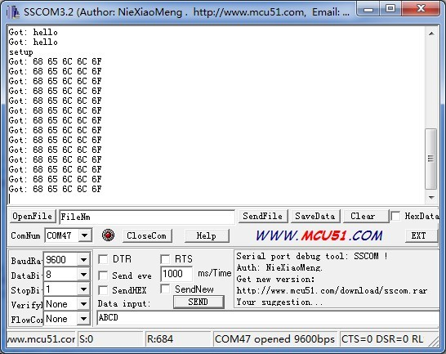
This is just a simple transmitter and receiver instance as a reference.

Version Tracker
Revision | Descriptions | Release
v0.9b | Initial public release | 03,Oct,2011

Resources
- File:VirtualWire Library.zip
- File:433MHz_demo.zip
- VirtualWire Documentation

Support
If you have questions or other better design ideas, you can go to our forum or wish to discuss.

